Use Case Specification: Submitting insurance benefits claim forms online

# Use Case 6

## Brief Description

This use case describes how visitors to KYHBPA’s website can submit insurance benefits claim forms online.

**1.2 Primary Actor**

User

# Flow of Events

## Basic Flow

1. User goes to KYHBPA website.
2. User clicks login button.
3. User enters username in username textbox.
4. User enters password in password textbox.
5. User clicks login button.
6. User clicks Insurance Benefits Claim Forms button.
7. User enters date of incident in date of incident textbox.
8. User enters name of horse in name of horse textbox.
9. User enters owner of horse in the owner of horse textbox.
10. User enters description of the incident in the description of incident textbox.
11. User enters name in Name textbox.
12. User enters phone number in Phone Number textbox.
13. User enters email in Email textbox.
14. The user clicks the submit button.
15. Submitting Insurance Benefits Claim Form confirmation page displays.
16. Use Case Ends.

## Alternative Flows

NONE

# Special Requirements

* Online payment system must be working properly
* Website must be secure enough to process payments safely.
* Donation form must be user-friendly and allow users to confidently and easily donate money to the KYHBPA.

# Pre-conditions

* User must navigate website to find the benefits claim form.
* The user must be an active member of the KYHBPA to claim benefits.

# Post-conditions

* The users benefits claim can be processed by the KYHBPA.

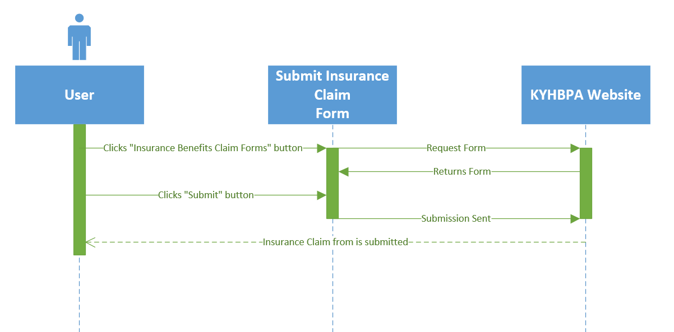

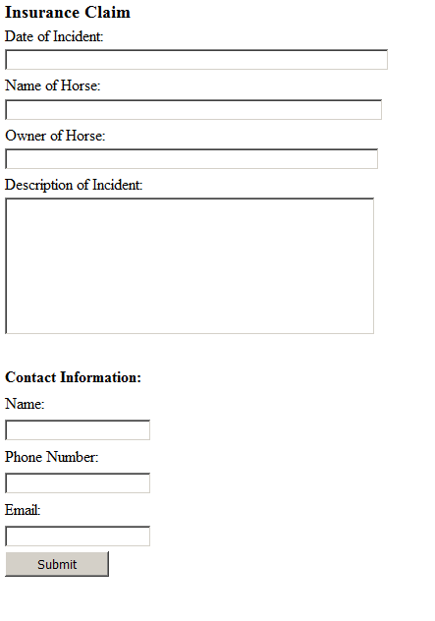

Use Case Specification: Tracking insurance benefits and insurance claims

# Use Case 7

## Brief Description

This use case describes how the KYHBPA can use the website and CMS to track all insurance benefit claims that have been submitted online.

**1.2 Primary Actor**

Admin

# Flow of Events

## Basic Flow

1. Admin navigates to Login class.
2. Admin enters username in username text box.
3. Admin enters password in password text box.
4. Admin clicks on the tracking forms button.
5. Admin clicks insurance benefits and insurance claims.
6. Admin clicks on the specific claim they want to track.
7. Use case ends.

## 2.2 Alternative Flows

* The website user can elect to submit insurance benefit claims offline.

# Special Requirements

* Website must be secure enough to process the insurance benefit claims.
* The plug-in required to track the claims must exist and be in good working order.

# Pre-conditions

* User must navigate website to find the insurance benefit claims form.
* The user must supply accurate information for KYHBPA to process it.

# Post-conditions

* Insurance benefit claims submitted online can be tracked by KYHBPA through their website.

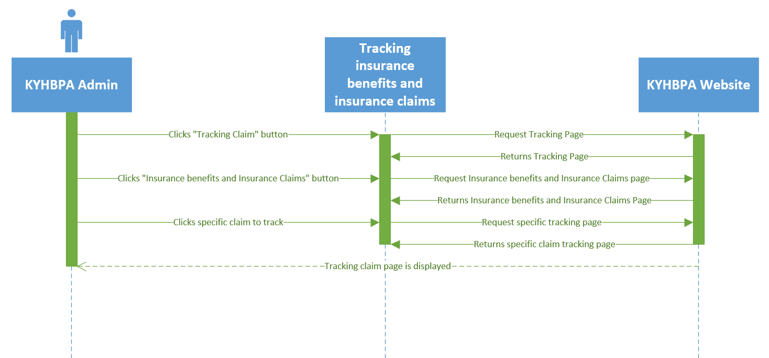

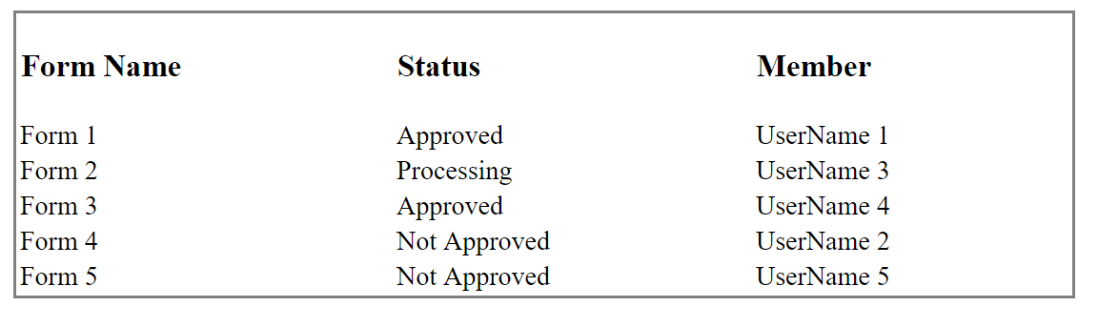

**Use Case Specification: Sending submissions to the KYHBPA office**

# Use Case 8

## Brief Description

This use case describes how the website can push all online submissions to the central administrative office of the KYHBPA.

**1.2 Primary Actor**

Website

# 2. Flow of Events

## Basic Flow

1. Use case is initiated when user clicks submit on a form.
2. Form gets pushed by CMS to administrative office of KYHBPA.
3. Form is easily accessible for review by KYHBPA team.
4. Use case ends.

## 2.2 Alternative Flows

NONE

# 3. Special Requirements

* The database must be accessible by the KYHBPA.

# 4. Pre-conditions

* The user must submit a form through the website.

# 5. Post-conditions

* The KYHBPA can access and retrieve the form.

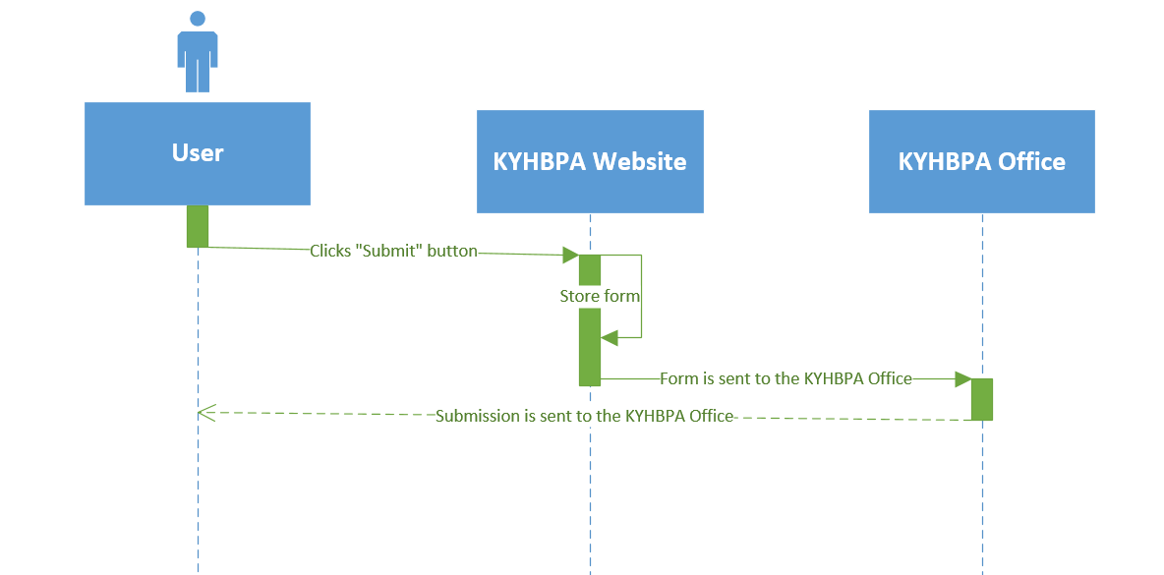



**Use Case Specification: Tracking racing commission forms**

# Use Case 9

## Brief Description

This use case describes how the KYHBPA can use the website to keep track of racing commission forms.

**1.2 Primary Actor**

Admin

# 2. Flow of Events

## Basic Flow

1. Admin navigates to Login class.
2. Admin enters user ID in the user text box.
3. Admin enters password in the password text box.
4. Admin clicks on the track forms button.
5. Admin clicks on the track racing commission form button.
6. Admin clicks on the specific form they want to track.

## 2.2 Alternative Flows

* The website user can elect to submit the form offline.

# 3. Special Requirements

* Website must be secure enough to process the racing commission forms.

# 4. Pre-conditions

* User must navigate website to find the racing commission form.

# 5. Post-conditions

* The racing commission form can be tracked by the KYHBPA online.

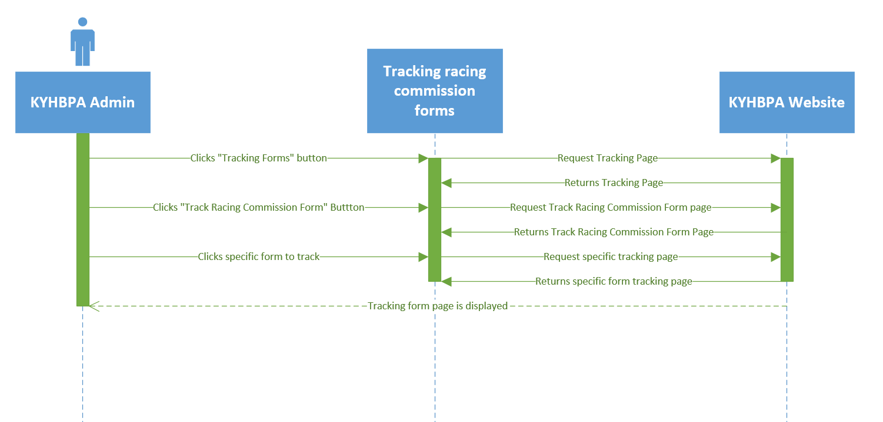

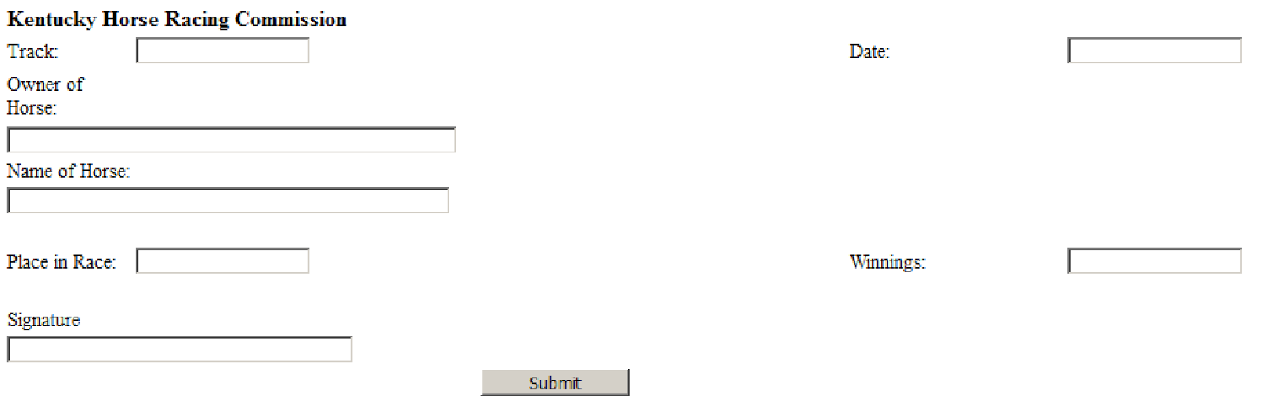

**Use Case Specification: Medication Forms**

# Use Case 10

## Brief Description

This use case describes how visitors to KYHBPA can provide downloadable and printable medication forms on the website.

**1.2 Primary Actor**

User

# 2. Flow of Events

## Basic Flow

1. The website user navigates to the medication forms page.
2. The user clicks print/download button next to the required form.
3. In response, the system will print or download a copy of the form for the user.
4. The user now has a medication form.

## 2.2 Alternative Flows

NONE

# 3. Special Requirements

* The user device must be able to download the form.
* The user must have the capability of printing the form.

# 4. Pre-conditions

NONE

# 5. Post-conditions

* The medication form is now accessible by the user.

